In Jupiter open the terminal and install

pip install spylon-kernel  
python -m spylon_kernel install  
pip install pyspark findspark

In jupoyter open spylon-kernal

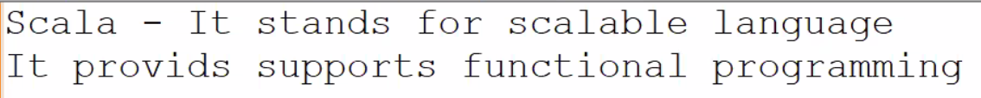  
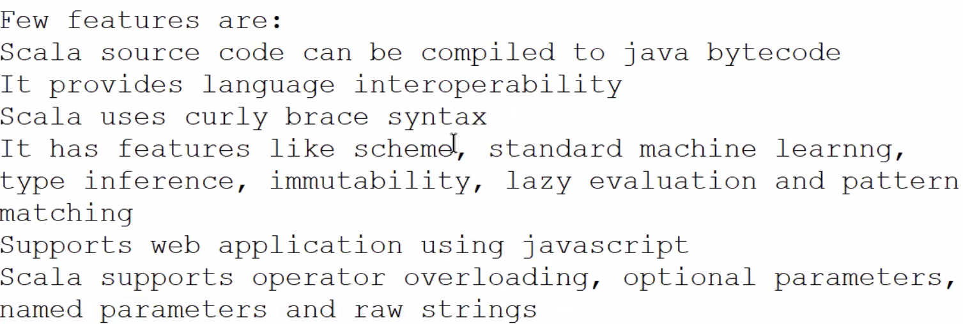  
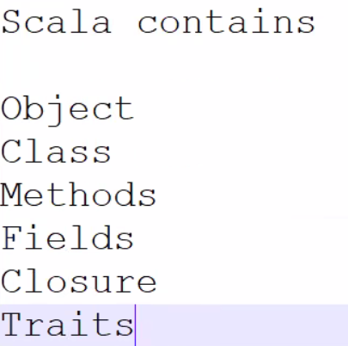

Scala is case-sensitive like python.

Classname in scala follows the pascal casing Where starting letter will be uppercase  
- officeAddress, getOfficeAddress

Programfile name it should be match the object name